**Pymaceuticals Inc.**

**Analysis**

* Add your analysis here.

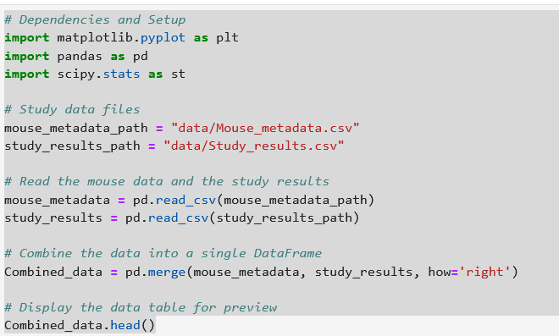

|  | **Mouse ID** | **Drug Regimen** |  | **Sex** | **Age_months** | **Weight (g)** | **Timepoint** | **Tumor Volume (mm3)** | **Metastatic Sites** |
| --- | --- | --- | --- | --- | --- | --- | --- | --- | --- |
| **0** | b128 | Capomulin |  | Female | 9 | 22 | 0 | 45.0 | 0 |
| **1** | f932 | Ketapril |  | Male | 15 | 29 | 0 | 45.0 | 0 |
| **2** | g107 | Ketapril |  | Female | 2 | 29 | 0 | 45.0 | 0 |
| **3** | a457 | Ketapril |  | Female | 11 | 30 | 0 | 45.0 | 0 |
| **4** | c819 | Ketapril |  | Male | 21 | 25 | 0 | 45.0 | 0 |

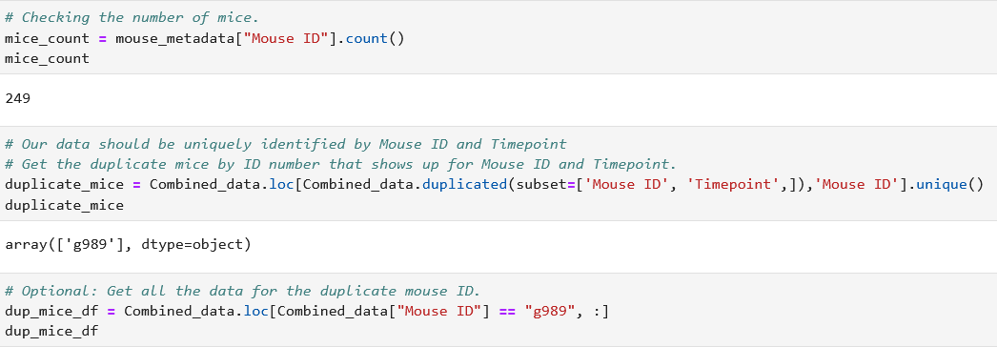

|  | **Mouse ID** | **Drug Regimen** | **Sex** | **Age_months** | **Weight (g)** | **Timepoint** | **Tumor Volume (mm3)** | **Metastatic Sites** |
| --- | --- | --- | --- | --- | --- | --- | --- | --- |
| **107** | g989 | Propriva | Female | 21 | 26 | 0 | 45.000000 | 0 |
| **137** | g989 | Propriva | Female | 21 | 26 | 0 | 45.000000 | 0 |
| **329** | g989 | Propriva | Female | 21 | 26 | 5 | 48.786801 | 0 |
| **360** | g989 | Propriva | Female | 21 | 26 | 5 | 47.570392 | 0 |
| **620** | g989 | Propriva | Female | 21 | 26 | 10 | 51.745156 | 0 |
| **681** | g989 | Propriva | Female | 21 | 26 | 10 | 49.880528 | 0 |
| **815** | g989 | Propriva | Female | 21 | 26 | 15 | 51.325852 | 1 |
| **869** | g989 | Propriva | Female | 21 | 26 | 15 | 53.442020 | 0 |
| **950** | g989 | Propriva | Female | 21 | 26 | 20 | 55.326122 | 1 |
| **1111** | g989 | Propriva | Female | 21 | 26 | 20 | 54.657650 | 1 |
| **1195** | g989 | Propriva | Female | 21 | 26 | 25 | 56.045564 | 1 |
| **1380** | g989 | Propriva | Female | 21 | 26 | 30 | 59.082294 | 1 |
| **1592** | g989 | Propriva | Female | 21 | 26 | 35 | 62.570880 | 2 |

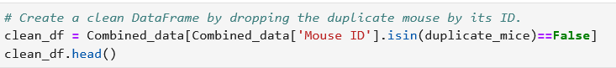

|  | **Mouse ID** | **Drug Regimen** | **Sex** | **Age_months** | **Weight (g)** | **Timepoint** | **Tumor Volume (mm3)** | **Metastatic Sites** |
| --- | --- | --- | --- | --- | --- | --- | --- | --- |
| **0** | b128 | Capomulin | Female | 9 | 22 | 0 | 45.0 | 0 |
| **1** | f932 | Ketapril | Male | 15 | 29 | 0 | 45.0 | 0 |
| **2** | g107 | Ketapril | Female | 2 | 29 | 0 | 45.0 | 0 |
| **3** | a457 | Ketapril | Female | 11 | 30 | 0 | 45.0 | 0 |
| **4** | c819 | Ketapril | Male | 21 | 25 | 0 | 45.0 | 0 |

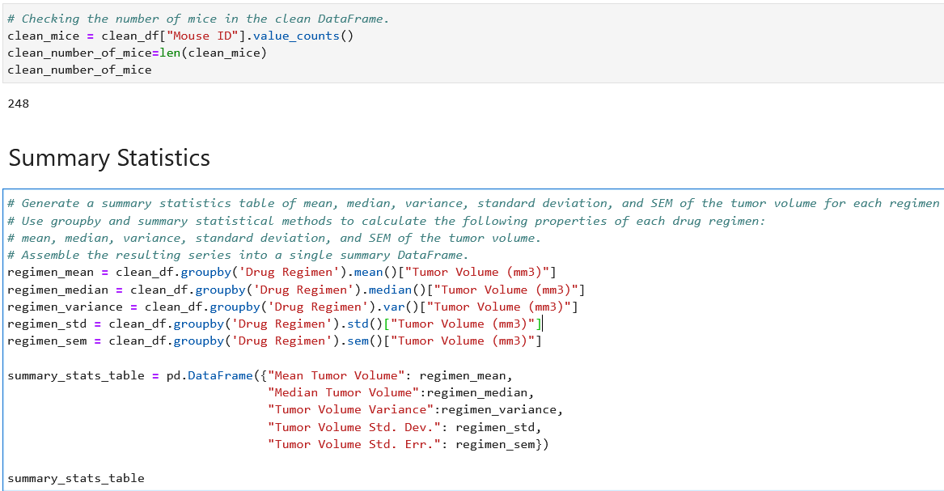

|  | **Mean Tumor Volume** | **Median Tumor Volume** | **Tumor Volume Variance** | **Tumor Volume Std. Dev.** | **Tumor Volume Std. Err.** |
| --- | --- | --- | --- | --- | --- |
| **Drug Regimen** |  |  |  |  |  |
| **Capomulin** | 40.675741 | 41.557809 | 24.947764 | 4.994774 | 0.329346 |
| **Ceftamin** | 52.591172 | 51.776157 | 39.290177 | 6.268188 | 0.469821 |
| **Infubinol** | 52.884795 | 51.820584 | 43.128684 | 6.567243 | 0.492236 |
| **Ketapril** | 55.235638 | 53.698743 | 68.553577 | 8.279709 | 0.603860 |
| **Naftisol** | 54.331565 | 52.509285 | 66.173479 | 8.134708 | 0.596466 |
| **Placebo** | 54.033581 | 52.288934 | 61.168083 | 7.821003 | 0.581331 |
| **Propriva** | 52.320930 | 50.446266 | 43.852013 | 6.622085 | 0.544332 |
| **Ramicane** | 40.216745 | 40.673236 | 23.486704 | 4.846308 | 0.320955 |
| **Stelasyn** | 54.233149 | 52.431737 | 59.450562 | 7.710419 | 0.573111 |
| **Zoniferol** | 53.236507 | 51.818479 | 48.533355 | 6.966589 | 0.516398 |

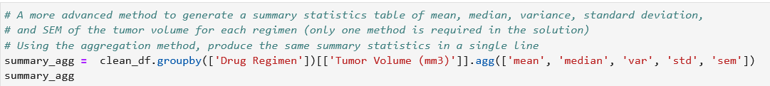

|  | **Tumor Volume (mm3)** | | | | |
| --- | --- | --- | --- | --- | --- |
|  | **mean** | **median** | **var** | **std** | **sem** |
| **Drug Regimen** |  |  |  |  |  |
| **Capomulin** | 40.675741 | 41.557809 | 24.947764 | 4.994774 | 0.329346 |
| **Ceftamin** | 52.591172 | 51.776157 | 39.290177 | 6.268188 | 0.469821 |
| **Infubinol** | 52.884795 | 51.820584 | 43.128684 | 6.567243 | 0.492236 |
| **Ketapril** | 55.235638 | 53.698743 | 68.553577 | 8.279709 | 0.603860 |
| **Naftisol** | 54.331565 | 52.509285 | 66.173479 | 8.134708 | 0.596466 |
| **Placebo** | 54.033581 | 52.288934 | 61.168083 | 7.821003 | 0.581331 |
| **Propriva** | 52.320930 | 50.446266 | 43.852013 | 6.622085 | 0.544332 |
| **Ramicane** | 40.216745 | 40.673236 | 23.486704 | 4.846308 | 0.320955 |
| **Stelasyn** | 54.233149 | 52.431737 | 59.450562 | 7.710419 | 0.573111 |
| **Zoniferol** | 53.236507 | 51.818479 | 48.533355 | 6.966589 | 0.516398 |

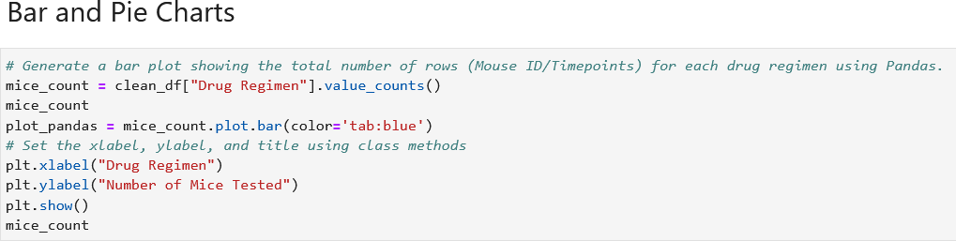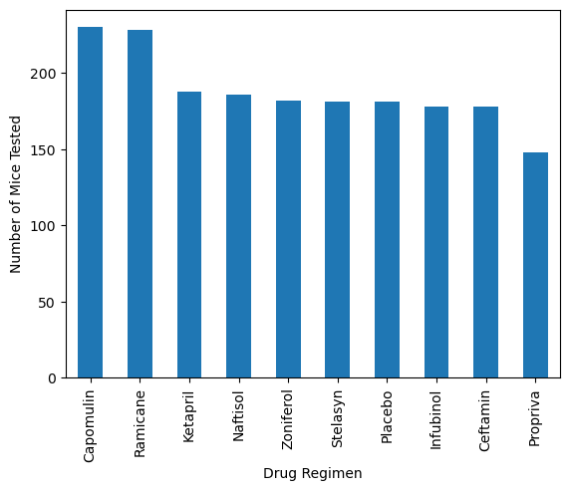

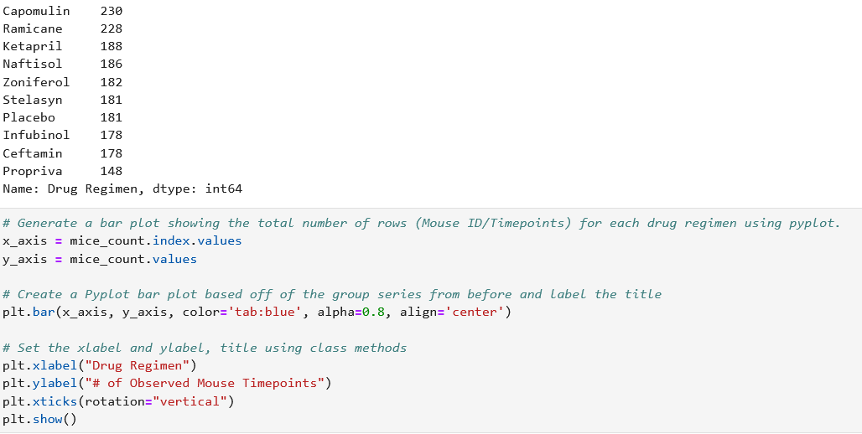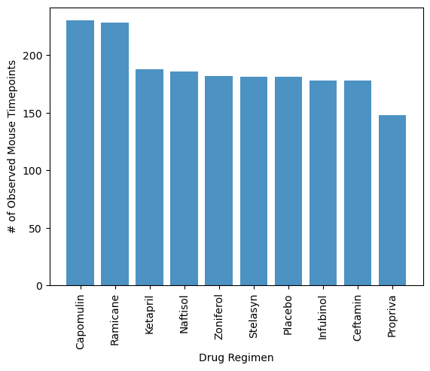

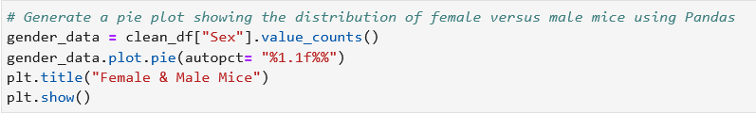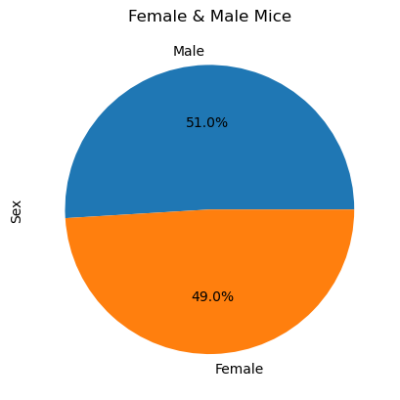

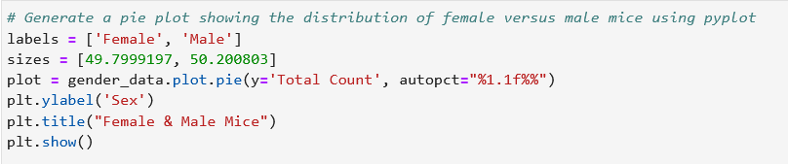

**Quartiles, Outliers and Boxplots**







